ØØ Explanation :
- We have a byte that is stored in H register.
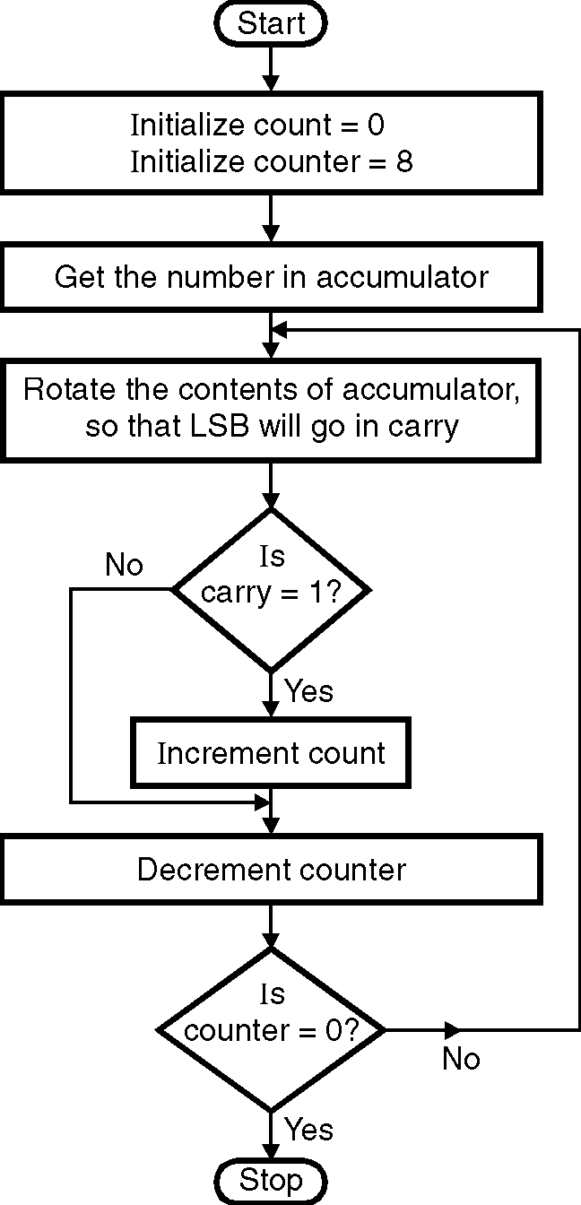
- Initialize the counter 1 = 8 i.e. total number of bits in a byte.
- Initialize counter 2 = 0 to count the number of 1’s.
- We will rotate the number in A alongwith carry by 1 bit to the right. If there is a carry we will increment counter 2.
- Decrement counter 1. This process will continue till all the bits are checked. The counter 2 will indicate the number of 1’s present in the byte.
- The result of counter 2 is stored in B.
- e.g. : H = 52 | - 0101 | - 0010
- Number of 1’s = 3
ØØ Algorithm :
Step I : Load the number in H register.
Step II : Initialize count in B = 00
Initialize counter 1 = 8.
Step III : Rotate contents of register so that LSB
will go in carry.
Step IV : Check if carry = 1. If not goto step VI.
Step V : Increment count in BL.
Step VI : Decrement counter 1.
Step VII : Check if counter 1 = 0. If not go to step III.
Step VIII : Store result in B.
Step IX : Stop.
ØØ Flowchart : Refer flowchart 29. Flowchart 29
ØØ Program :
Instruction Comment
MVI B,00H ; Initialize counter 1 =00 H
MVI C,08H ; Initialize counter 2 = 08 H
MOV A,H ; Load the number in accumulator
L2 : RAR ; Rotate the number alongwith carry
JNC L1 ; if no carry goto L1
INR B ; increment the count
L1: DCR C ; decrement counter 2
JNZ L2 ; check if counter = 0 ? if not continue
HLT ; terminate program execution

